1. Project Title
Slack Recipe AI Assistant using n8n and OpenAI

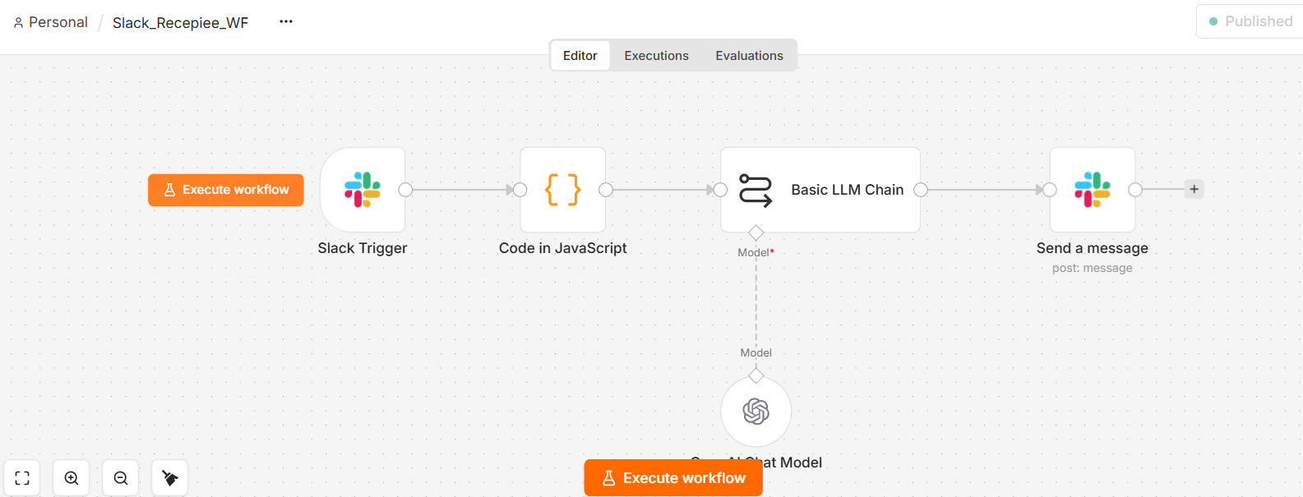

2. Problem Statement
The objective of this project is to build an AI-powered automation that works entirely inside Slack.
A user enters the name of a recipe in a Slack channel. The automation receives the recipe name, sends it to an AI model, generates the required ingredients and products, and automatically posts the shopping list back into the same Slack channel.
No separate application or website is required.
3. Solution
The solution uses n8n as the automation platform, Slack as the user interface, and OpenAI GPT-5-mini as the AI engine.
The workflow performs these steps:
- User mentions the Recipe AI Assistant in Slack.
- Slack sends the event to n8n.
- n8n extracts the recipe name from the Slack message.
- The recipe name is sent to the AI model.
- AI generates the required ingredients/products.
- n8n sends the AI response back to the same Slack channel.
4. Architecture
USER
│
▼
┌─────────────────┐
│ Slack #recipe-ai│
│ "chicken 65" │
└────────┬────────┘
│
▼
┌─────────────────┐
│ Slack Trigger │
│ App Mention │
└────────┬────────┘
│
▼
┌─────────────────┐
│ Code Node │
│ Extract Recipe │
└────────┬────────┘
│
▼
┌─────────────────┐
│ Basic LLM Chain │
│ Recipe Prompt │
└────────┬────────┘
│
▼
┌─────────────────┐
│ OpenAI GPT-5-mini│
│ AI Processing │
└────────┬────────┘
│
▼
┌─────────────────┐
│ Slack Send Msg │
└────────┬────────┘
│
▼
┌─────────────────┐
│ Slack #recipe-ai│
│ Ingredients List│
└─────────────────┘
5. Technologies Used
Technology | Purpose
Slack | User interface and messaging
n8n | Workflow automation
OpenAI GPT-5-mini | AI ingredient generation
JavaScript | Recipe extraction
Slack Events API | Sends Slack events to n8n
HTTP/Webhook | Connects Slack with n8n
6. n8n Workflow Nodes
Node 1 — Slack Trigger
Purpose: Detect when the user mentions the AI assistant.
Configuration:
- Trigger: Bot/App Mention
- Channel: #recipe-ai
- Channel ID: C0C1SCX5684
Example:
@Recepiee AI Assistant chicken 65

Node 2 — Code
The Code node removes the Slack bot mention and extracts the actual recipe.
const data = $input.first().json;

const text = data.text || "";

const recipe = text
.replace(/<@[^>]+>/, "")
.trim();

return [
{
json: {
recipe: recipe,
channel: data.channel,
user: data.user
}
}
];
For example:
Slack message:
@Recepiee AI Assistant chicken 65
becomes:
recipe = chicken 65

Node 3 — Basic LLM Chain
The AI prompt is:
Give me the complete list of products and ingredients needed to make {{$json.recipe}}.

Return the answer as a simple shopping list.
Include quantities where appropriate.
Do not include cooking instructions.
This makes the AI focus on ingredients/products, rather than cooking instructions.

Node 4 — OpenAI Chat Model
The workflow uses:
GPT-5-mini
The model receives the recipe extracted by the Code node and generates the ingredient list.

Node 5 — Slack Send Message
The AI response is posted back to the same Slack channel.
Message expression:
{{$json.text}}
Therefore, the user receives the result directly in Slack.
7. Example
User Input
@Recepiee AI Assistant chicken 65
AI Output
Chicken — 500 g
Corn flour — 4 tbsp
Rice flour — 2 tbsp
Ginger-garlic paste — 1 tbsp
Red chilli powder — 2 tsp
Turmeric powder — 1/2 tsp
Garam masala — 1 tsp
Lemon — 1
Curry leaves — 2 sprigs
Green chillies — 2
Oil — for frying
Salt — as required
The list is automatically posted back into #recipe-ai.
8. Key Features
- ✅ Works directly inside Slack
- ✅ No separate UI required
- ✅ AI-powered ingredient generation
- ✅ Automatic recipe extraction
- ✅ Automatic Slack response
- ✅ Quantities included where appropriate
- ✅ Real-time automation
- ✅ n8n workflow-based architecture
- ✅ Uses OpenAI GPT-5-mini
- ✅ Production webhook configured
- ✅ Workflow successfully tested in live mode
9. AI Component
The project demonstrates Generative AI integration with workflow automation.
The AI dynamically generates the required ingredients based on the recipe supplied by the user.
For example:
Recipe → Chicken Biryani
AI understands the recipe and generates an appropriate shopping list.
This means the ingredient list is not hard-coded into the workflow.
10. Automation Flow
User Request
↓
Slack
↓
Slack Events API
↓
n8n
↓
Extract Recipe
↓
AI Processing
↓
Generate Ingredients
↓
Slack
↓
User receives result
11. Testing
The workflow was tested with multiple recipes, including:
- Chicken Biryani
- Chicken 65
- Paneer Butter Masala
The workflow successfully:
- Received the Slack mention.
- Extracted the recipe.
- Sent the recipe to GPT-5-mini.
- Generated the ingredient list.
- Posted the result back to Slack.
12. Project Outcome
The project successfully implements an AI-powered Slack Recipe Assistant using n8n.
The complete interaction takes place within Slack. Users do not need to open another application to obtain the ingredient list.
Final Status
PROJECT STATUS: COMPLETED AND WORKING

